Lab tasks 01 by 21SW159

1. Sketch a java program which outcomes “Hello World” on computer screen.

**Source Code:**

class Task1 {

public static void main(String [] args){

System.out.println("Hello World");

}

}

**Output:**

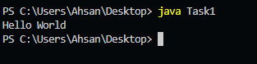

1. Write a java program to declare and initialize a double variable with a value such as 50.25. Then retrieve the integral part and the fractional part. Display actual number, integral part and Fractional part.

**Source Code:**

class Task1 {

public static void main(String [] args){

double a =50.25;

int b = (int)a;

float c = (float)(a-b);

System.out.println("Integeral part " +b);

System.out.println("Fractional part " +c);

}

}

**Output:**

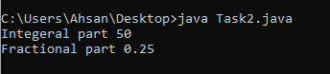

1. Write a Java program to print a face.

*Expected Output*

+ " " +

[| o o |]

| ^ |

| '-' |

**Source Code:**

class Task3 {

public static void main(String [] args){

System.out.println(" + \" \" + ");

System.out.println("[| o o |]");

System.out.println(" | ^ | ");

System.out.println(" | \'-\' | ");

}

}

**Output:**

